

**SCHOOL OF COMPUTING AND INFORMATICS**

**MASENO HOTLIB ANDROID APPLICATION**

**BY EMMANUEL ATEMBA**

**JOHN KAMAU GRACE MBIRA**

**(CI/00061/016) (CI/00011/016) (CI/00101/016)**

**A project proposal submitted in partial fulfillment of the requirements for the degree of Bachelor of Science in Information Technology Maseno University**

**SEPTEMBER 2018**

## DECLARATION

This project proposal is our original work and has not been submitted to any other institution of higher learning for any award.

**Signature___**

**_ _**

Date____ _

Registration No: CI/00061/016 Name: **Mutua Emmanuel Atemba** Signature_

Date____ _

Registration No: CI/00011/016 Name: **Kamau John Chege**

Signature_

Date____ _

Registration No: CI/00101/016 Name: **Mbira Grace Acholla**

This project has been given for examination with my approval as the project supervisor.

Signature_ _

Date____ _

Supervisor

**Mr. Gabriel Oliko**

# DEDICATION

This project is dedicated to **Our Parents,** strong and gentle souls who taught us to trust in the Almighty God, believe in hard work and that so much could be done with little. To **Our Lectures,** for equipping us with necessary advice, skills and knowledge. Lastly to **Our Fellow Students**, who have been always supportive and selfless in sharing resources?

**ACKNOWLEDGMENT**

We would like to express our sincere gratitude to our supervisor Mr. Gabriel Oliko for providing his invaluable guidance, comments and suggestions throughout the course of this project. We would specially thank Mr. George Omuono for constantly motivating us to work harder and always think outside the classroom.

Also, we would like to thank our friends George Kariuki and Jane Nduta for their prompt inspirations, timely suggestions with kindness, enthusiasm and dynamism.

**TABLE OF CONTENT**

DECLARATION i

DEDICATION ii

ACKNOWLEDGMENT iii

ABSTRACT vii

CHAPTER ONE 1

INTRODUCTION 1

* 1. PROBLEM STATEMENT 2
  2. EXISTING SYSTEM 2
  3. PROPOSED SYSTEM 3
  4. OBJECTIVES 3
  5. JUSTIFICATION 4

CHAPTER TWO 5

LITERATURE REVIEW 5

* 1. INTRODUCTION 5
     1. THE SCOPE OF REVIEW 5
     2. CRITERIA USED 5
     3. HISTORICAL BACKGROUND 6
     4. THE APPROACHES 7
     5. PREVIOUS STUDIES 7
  2. GENERAL CONCLUSIONS 11
  3. CONCLUSIONS 11

CHAPTER THREE 13

RESEARCH DESIGN AND METHODOLOGY 13

* 1. INTRODUCTION 13
  2. RESEARCH PROCESS SUMMARY 13
  3. RESEARCH DESIGN 14
  4. SYSTEM REQUIREMENT GATHERING AND ANALYSIS 15
     1. REQUIREMENT GATHERING: DATA COLLECTION 15

RESEARCH IN BOOKS 15

QUESTIONNAIRES 16

* + - 1. Construction and the structure of the questionnaires 16
      2. Distribution and Collection of the Questionnaires 17

INTERVIEWS 17

FOCUS GROUP INTERVIEWS 17

STRUCTURED INTERVIEWS 18

* + 1. ANALYSIS AND GENERATION OF THE REQUIREMENTS 18
       1. FUNCTIONAL AND NON FUNCTIONAL REQUIREMENTS 21
       2. FUNCTIONAL HARDWARE REQUIREMENTS 22
       3. SOFTWARE REQUIREMENTS 23
       4. PERFORMANCE REQUIREMENTS 24
    2. SYSTEM DESIGN 24
       1. USE CASE DIAGRAMS 24
       2. ACTIVITY DIAGRAMS 31
       3. SYSTEM SEQUENCE DIAGRAM 38

3.5.2 DATABASE DESIGN 39

3.5.2.1 INTERFACE DESIGN 44

* + 1. SYSTEM DEVELOPMENT 47
       1. DEVELOPMENT ENVIRONMENT: HARDWARE COMPONENTS 47
       2. DEVELOPMENT ENVIRONMENT: SOFTWARE COMPONENTS 47
    2. SYSTEM TESTING AND EVALUATION 48
       1. UNIT TESTING 48
       2. INTEGRATION TESTING 49
       3. SYSTEM TESTING 49
       4. USER TESTING 49

CHAPTER FOUR 50

RESULTS AND DISCUSSIONS 50

CHAPTER FIVE 53

CONCLUSION AND RECOMMENDATIONS 53

LIST OF REFERENCES 54

APPENDICES 55

GANNT CHART 55

QUESTIONNAIRE 1 56

QUESTIONNAIRE 2 57

QUESTIONNAIRE 3 58

# ABSTRACT

There is a need to have a system with necessary resources needed in undertaking a course for a specific study. This aids in revision and individual sharpening of skills outside the classroom setup. HotLib application seeks to fill the gap with an aim of providing such a platform in the university.

Maseno university school of computing is taken to be a representation of what happens in the whole campus. In the school currently WhatsApp is used as a basic means of communication between the lecturers and the students via a class representative. The class representative often has to remind lecturers the need of having notes at the beginning of a semester. Students in turn pressure the class representatives in their various WhatsApp groups. The notes and other resources may be sent but individual students who take long to go online go through unnecessary conversions and often miss out on the resources. This forces the class representative to again deal with the individuals in a personal conversation. Making it a tedious work. The HotLib application thus lightens the class representatives work by having each student download their own notes at a personalized time after a lecturer uploads them.

HotLib application is android based. This is because a majority of students use android phones. A student will be required to download the application to their phone and register into it. A separate web application will be created for lecturers to also register and use it to upload notes of all the units they teach in one setting. Once uploaded they are loaded to the application where registered students can access them and download them. Apart from notes the application provides links to authentic resources such as tutorials and also various challenges in the technology field that a student can use to sharpen their skills. Students will also be able to have revision material such as past papers, books and website links that are approved.

If this application is adopted to different schools, the students will have a comfortable learning experience with a site that enables them have authentic material without having to search the internet or pressure class representatives to ask for resources from lecturers on their behalf. Lecturers will have an easy task of distributing their notes. In that, they do not need to look for the necessary class representatives to give notes. They will easily upload all notes to different units in one sitting.

# CHAPTER ONE

## INTRODUCTION

In any institution of higher learning technology is a mediational tool that aids in facilitating learning. One of the key resources is having a platform where students can have ease of access to information as well as have the ability to engage with the institution in different levels so as to have ease in learning and undertaking research. Technology in the twenty-first century is rapidly developing hence it is important for institutions of higher learning to adapt to the ever-changing technological trends.

Maseno University one of the renowned universities in Kenya has a ratio of 300: 1 student to lecturers. With such a capacity, there exists a gap when it comes to student’s interaction with lecturers, access to books and periodicals from the library as well as study materials to guide students in their courses. There is need for an application that will fix the gap identified above. The application will contain academic forum platform that would present students an opportunity to forward their academic problems to a community of both lecturers and students.

Students in school of computing and informatics, experience challenges of having to look for lecturers to guide and give further information on a study, but this may at times be to no avail. Therefore, this proposal offers to develop a platform that offers academic materials from different lecturers in the School and will also offer revision materials that can be easily accessed by the great number of students in the school. The platform will also provide a forum to present academic challenges faced during learning. Lecturers will have the ability to upload their notes before a semester begins and therefore handle a group of students who are aware of the course outline and unit requirements. Material will be developed by lecturers and there after uploaded to the forum using a dedicated web application for the lecturers.

Having such an inter-linked platform will provide students with the ability to read ahead and have clearer understanding and interaction with lecturers during classes. It will also ensure students have in-depth revision when preparing for exams and having a wide number of

research fields to look into through the links in this forum. The lecturers will in-turn be able to

upload information directly to the students which will have less paper work and have real-

time access.

## PROBLEM STATEMENT

Students in the faculty of Computing and Informatics depend on their class representatives to collect class notes from the respective lecturers so that they can finally download the notes through WhatsApp Application. In the event that the class representative is not available or has not received the notes form the lecturer, all the students in that unit course remain in the dark. Receiving notes from the class representative through the WhatsApp Application groups can be inconvenient. A student who opens the application to view the updates on class issues may have to scroll up over 100 messages to find if there is any notes or assignment issued.

The school library serves more than 12,000 students and has a single computer from which they can access past papers. Therefore, students have to rely on each other to share the document once they take it from the library. Getting in touch with lecturers can be a hustle, considering some of the lecturers are part-time lecturers while others lecture both the main and the city campuses. Therefore, scheduling a consultation time with such lecturers proves difficult.

## EXISTING SYSTEM

The students in the school of computing use WhatsApp groups to receive notes from the class representatives. This system is not reliable because often the student has to scroll over 100 messages reading and ignoring some of them to check for updates on class assignments and lecture notes. In the event that the lecturer wants to share notes with the class directly, removable USB drives are used. These devices, though portable, they may contain malware that may infect the computers which they have been plugged into. The use of removable flash drives takes time as up to 30 minutes of the lecture time can be used to share notes or slides across the class.

Additionally, a student has to walk through offices looking for a lecture for consultations. The probability of getting the lecturer is low considering some of them are part-time while others lecture both the city and the main campuses. Relying on fellow students to help may also prove futile because often they may have found the same challenge and left it at that. Every

student requires enough resources to prepare for examinations. The university has only one library with a single serving computer that allows students to access past examination papers for revision. This system serves over 12,000 students from different faculties in the university. This only shows many students are left out.

## PROPOSED SYSTEM

The Hotlib application will be an android application what will allow students to download lecture notes uploaded by the respective lecturers. The lecturers will upload the notes using a web application. The android application will not only help students receive notes from the lectures, but also have the following features:

* + - A section to download past examination papers easily.
    - A discussion forum that will help students ask question and receive answers from other students and lecturers.
    - A section to provide extensive tutorials and online resources that will improve student learning process.
    - Well-structured challenges that the students may choose to solve. Once they complete a challenge, a new one originally locked or disabled is unlocked and enabled.
    - A quick link to student portal which opens the student portal inside the app.
    - A customized “HOW TO’s” feature to help student get quick responses on how to questions.
    - Technology section where student will be able to learn about what is trending and the latest in technology.

## OBJECTIVES

The following are the objectives of this proposed Maseno HotLib Project.

* + - To evaluate the current research trends on Android learning and resource sharing applications.
    - To identify issues associated with the current practices regarding learning and resource sharing in the university especially the School of Computing and Informatics.
    - To model a prototype of Maseno HotLib Android application.
    - To validate the Maseno HotLib Android Application.

## JUSTIFICATION

In the field of education especially at university level, students need access to resources. This is very fundamental in development of their skills and class performance. Having this kind of resources available on their mobile phones increases efficiency. In addition, students in the computing faculty of any institution should be able to understand the advancement of technology and its effects and be able to solve an existing problem using the best algorithm that addresses both memory space and time. Thus, having a mobile application that fetches resources, provides updated information and a forum for communication is essential.

This proposed application will aid in offering students technology resources, lecturers’ notes, past examinations as revision materials and a forum to present their difficulties and get quick feedback from their fellow students and lecturers. Elimination or reduction of long queues in the resource library will be possible because each student will be able to directly download the past examination papers using their mobile phones.

The proposed application will also assist the lecturers in uploading lecture notes using the dedicated web application specifically meant for them. The students will then be able to find all the uploaded notes in the application. The application will be a handy tool for the students because it will enable them receive notes in time and criticize delays.

In addition, the proposed application will help students attempt to solve programming challenges. The challenges will include tasks in PHP, JavaScript, Python, Java and many other computer languages. This will assist the students in advancing the skills learnt in class. This is very fundamental in development of student skills and class performance.

# CHAPTER TWO

## LITERATURE REVIEW

## INTRODUCTION

Traditionally, education has been offered in classes where students can interact directly with their teachers, making students’ physical presence very important. However, the wide distribution of computers and communication technologies has made the learning process easier. Since the arrival of mobile phones in the 1980s (Huet and Tcheng, 2010), they have been widely used by people of all ages all around the world. It could be said that the whole world is becoming mobile; mobile phones are not only communication devices, but also portable and private pieces of technological equipment. Nowadays, mobile technologies are becoming increasingly ubiquitous and networked. Such technologies can be used creatively in different areas. Using mobile technologies in education is a clear example of such an innovation. Mobile devices equipped with internet connections have created the need for a new form of electronic learning, called mobile learning. Internet-enabled mobile devices can help students to access learning resources and online courses, anywhere and at any time.

## THE SCOPE OF REVIEW

In the field of education especially at university level, students need access to the internet- available resources. This is very fundamental in development of their skills and class performance. Having this kind of resources right on their mobile phones is a good practice. In addition, students in computing faculty in any institution should be able to understand the advancement of technology and its effects and be able to solve an existing problem using the best algorithm that will address both memory space and time. Thus, having a mobile application that fetches resources, provides updated information and a forum for communication is good for them.

## CRITERIA USED

This literature review will be based on a research about the systems previously done, and which are related to this proposed system. The major focus will be on the android learning applications that assist students to develop and grow their skills. Six android learning application will be reviewed and investigated on how they have assisted the students in

both developing and growing their skills. The data collected about these various applications, will be analyzed and depending on the analyses, the proposed system will then be proved feasible or infeasible.

With the above in mind, existing literature will be investigated on mobile learning applications, key concepts of the applications outlined, major relationships or patterns noted, key strengths and weaknesses identified and the gaps in the research will also be outlined. The paper ends with a summary of agreements and disagreements in the literature, areas for further research and the overall perspective.

## HISTORICAL BACKGROUND

Many applications have been developed for mobile platforms. Over the last few years, these applications have been the focus not only of technical interest, but also marketing and business campaigns. Many applications have been developed for educational purposes (Demuynck and Laureys, 2002). Browsing sites such as Android Apps at the Google PlayStore shows the variety of learning applications for subjects such as different languages; concepts related to mathematics or programming languages, such as Quick Graph (2013) to calculate and design graph areas. In addition, one can find applications to learn about Islam and other religions (The Seerah App, Tarjimly 2017).

Recently, many researchers have focused on mobile technologies. This literature review will be based on a research about the systems previously done, and which are related to this proposed system. The major focus will be on the android learning applications whereby each of their strengths and weaknesses will be determined. Some researchers have defined the difference between e-learning and mobile learning, saying that e-learning is a learning process which is supported by digital electronic tools and media, and by analogy, m-learning is e- learning that uses mobile devices and wireless transmission (Pinkwartet al,2014). M-learning functions by integrating a number of hardware and software technologies into multimedia applications to facilitate the understanding of educational content, for example, in the form of quizzes or games. A 2010 study by Garajat the School of Engineering and Design, Brunel University, United Kingdom, was designed to enhance students’ performance and experiences within the BSc. Multimedia Technology and Design course. The research presented a number

of m-learning application concepts organized under the subjects of administration,

presentation, feedback, motivation, and innovation. The study found that implementing m-

learning is sufficient for students.

## THE APPROACHES

The approaches towards this review will be based on the android learning applications that assist students in development of skills. Therefore, the functionalities of these applications will be determined and their strengths and weaknesses evaluated. To achieve this, The Internet and The Library (Secondary methodology) were the main research methods used.

## PREVIOUS STUDIES

After doing a broad research in the field of Education and Technology, the following android application were found to assist students in different levels of study. Such applications include the following:

## BBC Bitesize

BBC Bitesize (2003; 2004) is an initiative to provide revision materials via mobile phones, using a downloadable Java game and SMS text messages. Given the limited amount of information that can be displayed on-screen and sent via text, the revision materials really are ‘bite-sized’. This initiative has been running since 2003, and has proved to be very popular, especially with the growing number of phones with Java capabilities. The main impact of the BBC Bitesize program comes from the size of its audience – over 650,000 GCSE students (as well as a number of curious adult learners).

Some implementation problems highlighted include:

* Problem of localized content: some questions were not relevant to what a particular student had studied.

Lack of detailed feedback for learners: the small screen size and memory capacity of the mobile phones meant that no detailed feedback about question responses could be given. This was highlighted as a key issue that learners wanted to see addressed.

Compatibility across devices: despite Java being promoted as a cross- platform environment, it was difficult to get the Java game running on all phones.

* Costs: the SMS service was originally free, but excessive demand forced the BBC to charge for messages, leading to a significant decline in popularity.

## PhotoMath

PhotoMath is one of the more focused learning apps developed by MicroBlink in 2014. As the name implies, this one is all about math. It uses your camera and OCR technology to read equations that you write down. Photomath will help you interpret problems with comprehensive math content from arithmetic to calculus to drive learning and understanding of fundamental math concepts. It then gives you the answer. More importantly, it shows you the step-by-step procedure on how it came up with the answer. Thus, it gives you the answer and teaches you how to solve the problem. A lot of people struggle with math and an app like this can help. The free version provides the basic features. Going pro will get you the step-by- step instructions for completing equations, better explanations, and extra math resources. The application has a smart calculator that allows one to enter or edit scanned math problems using intuitive math keyboard. Experiment with changes to get a deeper understanding of math problems. The application also includes graphs. Uses graphs to visualize math problems. You can not only explore graph details such as the root, the domain, etc. but also use graphs to interpret solutions of equations and system of equations.

The drawback backs of this application include the following:

* + It only focuses on math problems and it does not address other learning fields such as programming and networking.
  + The application has both paid and free version. The free version gives the answer to the scanned mathematics problems. While that is important, it also benefits the learner to understand the steps used to arrive at the answer. This feature is included in the paid or the pro version of the application. In other words, a learner must pay to get this features.
  + The application only works with arithmetic equations and not word problems. So the learner must first summarize the question into related arithmetic equations so as to scan the problems using the camera of the mobile phone.

## Quizlet

Quizlet is a free online study tool launched in 2007 that students may use to choose from a variety of interactive study activities including flashcards, matching activities, and other learning games. Students can create their own study sets, use existing sets that have been shared in Quizlet, and can even join a course Quizlet page if the instructor has created one. Quizlet can be used within a learning management system (LMS), or can be shared with students via email or web URL. Quizlet can be used in any course where students must memorize definitions or terms, or must associate a word or definition with a sound or picture. For example, students can use Quizlet to learn terms for biology, to study vocabulary for a foreign language, or to study events and dates for a history course. Some of the advantages of incorporating flashcards and the other learning games into your courses are that they:

* + - Promote active learning
    - Provide a chance for self-assessment.
    - Provide immediate feedback
    - Allow students to be less self-conscious during practice
    - Provide challenges with attainable goals and known

However, the app focuses on the courses that require memorization of terms this makes it difficult to use it in the environs that mastery of concepts is highly recommended. Also the app has free version which gives a learner a limited number of flashcard sets to use. The pro version is expensive to acquire.

## Udacity

Udacity android application (2016) allows one to master in-demand skills in today’s hottest fields, through learning programs built with the world’s most innovative companies. One can use Udacity app to fully manage personalized learning experience. The courses they offer are generally about super specific, in-depth topics. Completion of those classes often bestows upon the student a nanodegree in the topic. Thus, there is a prove you finished it. The company also frequently makes the news for having courses from industry leaders like Google, Facebook, and others. One can access Master course material developed with industry experts from Facebook, Google, Amazon, GitHub, and more. One can access the classroom, connect with mentors, and track their progress. Download classes and content ahead of time for future offline work sessions. Get the skills needed to succeed in fie lds like Data Science, Artificial Intelligence, Digital Marketing, Web and App Development, and

more. The Udacity mobile experience delivers world-class content, via an innovative platform, with optimal flexibility. However most of the courses offered at Udacity are sold, and they can be very expensive as some like Artificial Intelligence courses are offered at

$999.

## Wolfram Alpha

Wolfram Alpha (2009) is a unique engine for computing answers and providing knowledge. It works by using its vast store of expert-level knowledge and algorithms to automatically answer questions, do analysis and generate reports. Its long-term goal is to make all systematic knowledge immediately computable and accessible to everyone. Wolfram Alpha works to accept completely free-form input, and to serve as a knowledge engine that generates powerful results and presents them with maximum clarity. Wolfram Alpha is an ambitious, long-term intellectual endeavor that intends to deliver ever-increasing capabilities over the years to come.

The cons of using Wolfram Alpha includes copying answers without an understanding of concepts, the time consuming distractions with content containing non mathematical topics, and students not paying attention in during instruction with the intention of just looking up the answer later. Also Questions must be specific to get an answer (for example you can just search "dogs" you need to search a specific breed to get an answer). Students rely too much on technology for the answers, instead of doing the work themselves.

The app also has occasional connection issues and it can be acquired with $2.99. Too much for students.

## Udemy

Udemy (2014) was one of the first education apps on mobile to offer up the courses. It currently boasts over 32,000 courses in total that range from science and technology to cooking and foreign language. Some of the other topics include business, marketing,

entrepreneurship, design, health and fitness, music, photography, and there are even courses to help you learn software. The courses range greatly in terms of quality of content. There are both free and paid courses as well. The app is pretty decent and carries most of the features of the official website as well. Many instructors add supplemental resources to lectures as a means to enhance the learning experience of the course. These resources can quickly be accessed on the Udemy Android app to be viewed.

However, most courses cost a nominal fee to access with the cheapest costing about $10.99. Also lots of “low quality” courses (made by instructors trying to make a quick buck recording course videos). Strong internet is required to access these course materials.

## GENERAL CONCLUSIONS

After analyses of the review was done, the findings were that there is still not yet an android application that will assist the students get notes easily from their respective lectures, a web application that allows lectures log in and upload the lecture notes and assignments/take away cats, download past examination papers which have been uploaded by the librarian. There will be need for an android application that will assist students get lecture notes easily from their lectures and also get the past examination papers right through their phone.

## CONCLUSIONS

In conclusion, the above literature review shows that there are efforts to assist students develop and grow their skills by making resources available on their mobile phones. Some have also gone an extra mile of providing a replicate or even an advanced website where students interact with tutors during online classes. Unfortunately, most of this android application are in purchase apps.

As a result, this literature review permits and qualifies the implementation of an android application that will not only handle in job skill growth and development but also the basic class fundamentals such as the lecture notes and the past examination papers.

## CHAPTER THREE RESEARCH DESIGN AND METHODOLOGY

## INTRODUCTION

Examining the variables related to Kenyan Education System and the enhancement of the Technology in the world and the contribution of these variables to the improvement of learner achievement demands a dynamic research approach that is firmly rooted in both qualitative and quantitative epistemologies. This is necessary to ensure that the respondents (Students, Lecturers and the Education System) in a study of this magnitude and complexity are not denied their subjective views on the phenomena being studied, while the objectivity of the entire research enterprise is guaranteed. In line with this thinking, this study is based on a mixed methods research approach which is explained in detail in the following sections.

## RESEARCH PROCESS SUMMARY

After identification of the research problem or an area of interest, the researcher has to identify

Appropriate method(s) to approach the problem. In order to give direction to this study, the

Research process shown below was adopted. The research process provides a summary of the important issues that were taken into consideration and reviewed before undertaking the research. The different steps in the diagram serve as a basis from which to consider the following: the philosophical orientation of the researcher; the research approach adopted; appropriate research strategies; the research time lines that are under review; and the data collection techniques employed by the researcher.

## FIGURE 3.1 RESEARCH PROCESS SUMMARY



**PHASE 0**

**Preparation**

**PHASE 1**

**Literature Review**

**PHASE 2**

**Theories and Assessment tools**

**PHASE 3**

**Data Gathering**

**PHASE 4**

**Data Analysis and Conclusions**

1. Project Plan
2. Research

Methodology

1. Historical

Information

1. Industry Information
2. Review of the Related Studies

1. Theoretical

Foundation 2.Questionnaire Based on the chosen Model

1. Questionnaire

Distribution

1. Gathering of Answered questionn- aire

1. Analysis of Ma-

Seno HotLib 2.Recommendatio n

For Future works

* 1. **RESEARCH DDESIGN**

Leedy (1997) defines research design as a plan for a study, providing the overall framework for collecting data. MacMillan and Schumacher (2001) define it as a plan for selecting subjects, research sites, and data collection procedures to answer the research question(s). They further indicate that the goal of a sound research design is to provide results that are judged to be credible. For Durrheim (2004), research design is a strategic framework for action that serves as a bridge between research questions and the execution, or implementation of the research strategy. Quantitative research, according to Van der Merwe (1996), is a research approach aimed at testing theories, determining facts, demonstrating relationships between variables, and predicting outcomes.

Quantitative research uses methods from the natural sciences that are designed to ensure objectivity, generalizability and reliability Weinreich, (2009). The techniques used in quantitative research include random selection of research participants from the study population in an unbiased manner, the standardized questionnaire or intervention they receive, and statistical methods used to test predetermined hypotheses regarding the relationship between specific variables. The researcher in quantitative research, unlike in the qualitative paradigm where he/she is regarded as a great research instrument due to his/her active participation in the research process, is considered as being external to the actual research, and results are expected to be replicable, no matter who conducts the research.

Qualitative research, according to Van der Merwe (cited by Garbers, 1996) is a research

approach aimed at the development of theories and understanding. Denzin and Lincoln (2005)

define qualitative research as a situated activity which locates the observer in the world. It involves an interpretive, naturalistic approach to the world, i.e. qualitative researchers study phenomena in their natural settings, attempting to make sense of, or interpreting phenomena in terms of the meanings people bring to them. Qualitative research implies an emphasis on the qualities of entities and on processes and meanings that are not experimentally examined or measured (Denzin & Lincoln, 2005).

## SYSTEM REQUIREMENT GATHERING AND ANALYSIS

## REQUIREMENT GATHERING: DATA COLLECTION

This is a mixed methods research where both qualitative and quantitative methods of data collection where used to study of the variables related to Kenyan Education System and the enhancement of the Technology in the world and the contribution of these variables to the improvement Given this focus, literature reviews, questionnaires and interviews were used to collect data. According to Van der Merwe (1996:290), in theoretical studies the researcher produces his/her evidence to support arguments from existing facts or information.

## RESEARCH IN BOOKS

This study focuses on variables related to mobile learning applications and their contribution to the improvement in the performance of learners in the matriculation examination. For this purpose, an extensive and relevant literature review was conducted in an attempt to provide a theoretical foundation for the research project. The literature review provided scientific explanations for the research question(s), and enabled to verify the researchers’ findings and to compare these with the work of other scholars in the field of mobile development and education.

According to Neuman (1997:89), a literature review is based on the assumption that knowledge accumulates and that we learn from, and build on, what others have done. Literature reviews can take various forms, namely: contextual, historical, theoretical, integrative, and methodological and meta-analysis. Each type of review has a specific goal. Neuman (1997:89) indicates that the goals of a literature review are: demonstrating the researcher’s familiarity with a body of knowledge that already exists about the subjects of research and establishing the credibility of such knowledge; showing the path of prior research and how the current project is linked to already completed research; integrating and

summarizing what is known in and about his/her area of research; learning from others; and stimulating new ideas.

This study, in line with Neuman‘s (1997) goals above, used existing literature to investigate the mobile learning applications by exploring the widely accepted models, definitions and theories of mobile development, and how the concept manifests itself as an accepted practice in the improvement of learner achievement.

## QUESTIONNAIRES

A questionnaire is a form containing a set of questions, especially addressed to a statistically significant number of subjects, and is a way of gathering information for a survey. It is used to collect statistical information or opinions about people. The Oxford Advanced Learner‘s Dictionary (1997:952) defines a questionnaire as a written or printed list of questions to be answered by a number of people, especially as part of a survey. For the purpose of this study, the questionnaire formed the second data collection method and its content was guided by the literature reviewed. Assistance from the Information Technology department in the school of computing and informatics was sought, particularly with regard to validity of items for statistical purposes. The questionnaire was administered to the 100 students in the Faculty of Computing, as well as their Lecturers, Head of Departments and Chairmen.

## CONSTRUCTION AND THE STRUCTURE OF THE QUESTIONNAIRES

Structured questionnaires were used as research instruments for the first section of this study. The literature review was used to construct two different questionnaires, one for students and another one for Lecturers and Librarians. The purpose of the questionnaire for students was to find out how they get learning resources. The purpose of the questionnaire for the Lecturers in the school of Computing and Informatics was to gather information concerning their perception with regard to the role of technology in the Faculty and how they deliver their lecture notes to students and lastly the questionnaire for librarians were used to find out how many students get past papers from the library and how many computers help them in the process.

## DISTRIBUTION AND COLLECTION OF THE QUESTIONNAIRES

As indicated in the sample and sampling procedures described below, the target sample was the 50 students from all the departments in the Faculty of School of Computing and Informatics. The purpose of the questionnaire was to investigate and document the contribution of the independent variables which characterize old art of education and its effect on the dependent variable, which is learner performance.

The following methods were used to distribute and collect the questionnaires:

* The questionnaires were packaged according to the four departments in the Faculty and submitted to the class representatives for delivery to the students in that department.
* The class representatives were contacted using WhatsApp Application to collect the questionnaires and requested to expedite the completion of the questionnaires.

Each department‘s questionnaire consignment consisted of one questionnaire for the students and two questionnaires numbered (a) for the lecturers and (b) for the students.

* Some class representatives submitted the completed questionnaires from their department to the desk.
* Only 1 out of the 4 departments did not participate in the completion of the questionnaires.

## INTERVIEWS

Seale, Giampietro, Gubrium and Silverman (2004) define an interview as a social encounter Where speakers collaborate in producing retrospective and prospective accounts or versions Of their past or future actions, experiences, feelings and thoughts. Two types of interviews Were used in this study, namely focus group interviews and structured interviews.

## FOCUS GROUP INTERVIEWS

Focus group interviews were conducted first, followed by the one-on-one interviews. The purpose of this exercise was to assist the researcher in formulating relevant questions for development of questionnaires.

## STRUCTURED INTERVIEWS

Structured interviews were conducted with students conveniently sampled from the 50 students who participated in this study and the responses were recorded with their permission. This induced first-hand information from the students with regard to their experiences, challenges, technical issues and opinions. An interview schedule was compiled in which the interview questions are outlined.

## ANALYSIS AND GENERATION OF THE REQUIREMENTS

Three sources of data were identified for this study, namely interviews and a questionnaire which are referred to as primary sources of data, and a literature review as secondary data. (Mouton, 2006:164). Secondary data is collected for the primary purpose of re-analyzing the data, and has the advantage of compelling the researcher to be explicit about the underlying assumptions and theories pertaining to the data. Onwuegbuzie and Teddlie (2003) state that when analyzing qualitative and quantitative data within a mixed methods framework, researchers undergo at least seven stages, which is the procedure that was used in this study. The following table represents the operation of the seven stages in the data analysis process:

|  |  |  |  |
| --- | --- | --- | --- |
| **Stages in the mixed methods data analysis process** | **Description of each stage** | **Application in quantitative data analysis** | **Application in qualitative data analysis** |
| 1.Data Reduction | Reducing the dimensionality of the qualitative and quantitative data | Via descriptive statistics, exploratory factor analysis and cluster analysis | Via exploratory thematic  Analysis |
| 2. Data Display | Pictorially describing both the qualitative and quantitative data | Using tables and graphs | Using matrices, charts,  graphs, networks, lists,  rubrics, and Venn diagrams |
| 3. Data Transformation |  | Quantitative data are converted into narrative data that can be analyzed qualitatively | Qualitative data are  converted into numerical  codes that can be  represented statistically |
| 4.Data Correlation |  | Quantitative data is correlated with qualitative data | Qualitative data is correlated with quantitative data |
| 5. Data | Both qualitative and |  |  |

|  |  |  |  |
| --- | --- | --- | --- |
| Consolidation | quantitative data are combined to create new/consolidated variables |  |  |
| 6.Data Comparison | Involves comparing data from both the qualitative and quantitative data sources |  |  |
| 7.Data Integration | This is a final stage, wherein both qualitative and quantitative data are integrated into either a coherent whole or two separate sets of coherent wholes | | |

## FUNCTIONAL AND NON FUNCTIONAL REQUIREMENTS

* + - 1. **FUNCTIONAL REQUIREMENTS**

This section contains the requirements for the Maseno HotLib android application. The functional requirements, as collected from the users, have been categorized as follows to support the types of user interactions that the system shall have.

* + - * 1. **Educational Purpose:** The Maseno HotLib android application will assist students understand the concepts of android app development using android studio and java as its event driven language

**FR01:** The students shall be able to view the source code for the entire application.

**FR02:** The students shall be able to, individually, view and understand the code for all pieces on the UI.

**FR03:** The students shall be able to test the Maseno HotLib android application on different devices and understand the importance of building responsive application.

**User: Download Lecture notes, Past Exams, attend to challenges, ask the forum** The users shall be able to download the lecture notes uploaded by the lecturers using the application. They will also be able to download past examination papers from the application.

**FR04:** The users shall be able choose the Course they are doing from a dropdown.

**FR05:** The users shall be able to choose the units they want to download notes

**FR06:** The users shall be able to download examination past papers from the application.

**FR07:** The users shall be able to attend to challenges in the application to gauge their skills and understanding.

**FR08:** The users shall be able post questions to the forum module and get questions from the members concerning different programming languages.

**FR09:** The users shall be able to search “how to” questions easily.

## Login/ User Authentication

**FR010:** The users shall login or register using the user authentication form.

**FR011:** The users shall not login or register if the information is incomplete or invalid.

## Admin: View User Information

**FR012:** The administrator shall be able to view all the users’ information.

## 4. Lecturer: Upload notes, Assignments and Take Away CATs

**FR013:** The lecturer shall be able to upload notes using a dedicated website to the application.

**FR014:** The lecturer shall be able to upload class assignments using a dedicated website to the application.

**FR015:** The lecturer shall be able to upload Take Away CATs using a dedicated website to the application.

**FR016:** The lecturer shall be able to upload Lab Practices using a dedicated website to the application.

## NON-FUNCTIONAL REQUIREMENTS

This sections describes the existing non-functional (also referred to as Quality of Service by the International Institute of Business Analysts, Business Analysis Body of Knowledge), technical environment, systems, functions, and processes. Includes an overview of the non- functional requirements that will be used to achieve the project’s objectives.

## HARDWARE REQUIREMENTS HR01: Laptop

A laptop to allow installation of necessary software for development of the Maseno HotLib Android application.

**Brand:** Toshiba brand will be used to develop the application.

**Processor:** Intel® Core™2 Duo CPU T8300 @ 2.40GHz × 2

## HR02: RAM and ROM

For the necessary software to be installed and run on the laptop or computer storage specifications will be as follows.

**Hard Disk:** 500GB hard drive was used.

**Brand:** Toshiba Hard disk.

**RAM:** 6GB RAM was used

**Brand:** Intel chipset 3 DRD

## HR03: Printer (HP LaserJet M4555 MFP PCL 6)

To be used printing of documentation as well as development of the reporting in the system.

**Dimensions (WxDxH)-** 44.55 cm x 67.94 cm x 8.73 cm,

**Power**: AC 120/230 V,

**Networking:** GigE, 10 GigE,

## HR04: Flash Disk (4GB)

Used as a storage device for materials which were obtained from the internet and transferred to the working environment.

**Brand:** Hp flash disk.

## SOFTWARE REQUIREMENTS

**SR01: Linux Destro Operating System**

Used as the interface between the user and the hardware. Allows installation of Applications.

**Brand:** Kernel Linux 4.18.0-parrot10-amd64 x86_64

## SR02: Android Studio

Used to develop the android application using Java and XML.

**Version:** Android Studio version 3.5.9

## SR03: Balsamiq Mockup

Used to develop a mockup of the Maseno Android Application with links to link different pages.

**Version:** Balsamiq 7.9

## SR04: Gantt Project

Used to develop a Gantt chart to assist in time allocation per activity

**Version:** 6.57

## PERFORMANCE REQUIREMENTS

This section lists the performance requirements expected from the Maseno HotLib Android Application.

**PR01:** The users shall be able to download lecturer notes and past examination papers in less than 5 seconds if the network is fast.

**PR02:** The users shall be able access the revision materials (internet resources) in less than 5 seconds depending on their connectivity.

**PR03:** The navigation between challenges shall take fewer than 5 seconds.

**PR04:** Uploading notes shall take less than 6 seconds depending on the internet connectivity of the lecturer.

**PR04:** The application shall be able to do a validation check on the information provided in the user-authentication form to avoid false or incomplete information.

## SYSTEM DESIGN

## USE CASE DIAGRAMS

The use cases of the Maseno HotLib application are divided among the students, the lecturers, the librarians and administrator of the application.

## The Student

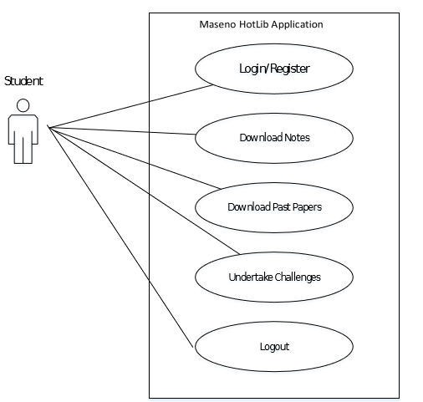

**Use Case name:** Register

* + - * + **Description:** This use case describes the scenario where the user/student registers with the application by providing all the necessary details, in order to access the application.
        + **Actor:** Student
        + **Input:** The user or the student will have to provide all the necessary details present in the user registration form of the application.
        + **Output:** All the details entered in the user registration page will be verified and accepted by the system into the database.

**Use Case name:** User Login/Logout

* + - * + **Description:** This use case describes the scenario where the user logs into the application, with the username and password he has provided while registering with the system.
* **Actor:** Student
* **Input:** The user or the student creates a username and password at the time of registering with the system. He then uses them to logon to the system and download lecturer notes and past papers besides other functions.
* **Output:** The application then verifies the authenticity of the username and password that the student has provided and allows the user to view the information available on the application, if the username and password are valid.

**User Case name:** Download Notes

* **Description:** This use case describes the scenario where the student makes appropriate choices before proceeding .to download the lecturer notes.
* **Actor:** student
* **Input:** The student makes choses such as the course he/she does, the unit code and the semester.
* **Output:** The application will display notes depending on the choices made above and prompt the student to download the notes.

**User Case name:** Download Past papers

* **Description:** This use case describes the scenario where the student makes appropriate choices before proceeding .to download the past papers.
* **Actor:** student
* **Input:** The student makes choses such as the course he/she wants the past papers for and the academic year the examination was done.
* **Output:** The application will display past papers depending on the choices made above and prompt the student to download the past papers.

## The Administrator

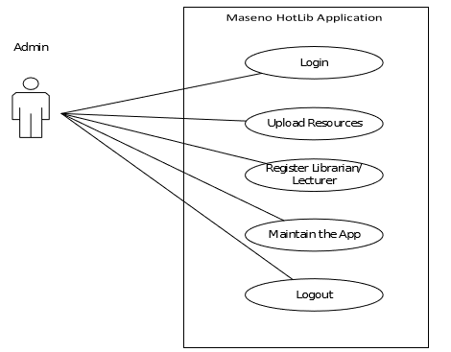

**Use Case name:** Login/Logout

* + **Description:** This use case describes the scenario where the administrator of the application, logs into the system and logs out after the work is done.
  + **Actor:** Admin
  + **Input:** The administrator of the application logs into the application with the username and password provided to him.
  + **Output:** The application verifies the authenticity and displays the home page of the administrator.

**Use Case name:** Upload Resources

* + **Description:** This use case describes the scenario where the admin uploads resources to the application.
  + **Actor:** Admin
  + **Input:** The administrator of the applications logs onto the system with his username and password.
  + **Output:** The application authenticates the administrator, and then displays the page where the administrator can upload resources to the application.

**Use Case name:** Register Librarian/ Lecturer

* + **Description:** This use case describes the scenario where the administrator registers unregistered lecturers and librarians to the application.
* **Actor:** Admin
* **Input:** The administrator logs onto the system with the username and password provided to him.
* **Output:** The application authenticates the administrator, by verifying the username and password. Then the application displays the page where the administrator can add new lecturers and librarians to the application.

**Use Case name:** maintain the app

* **Description:** This use case describes the scenario where the administrator logs onto the application to modify the details of the system.
* **Actor:** Admin
* **Input:** The administrator logs onto the application with the username and password provided to him
* **Output:** After verifying the username and password of the administrator, the application then allows the administrator to login. The administrators can then browse through the application and change the details of any module of the application.

## The Lecturers and Librarian

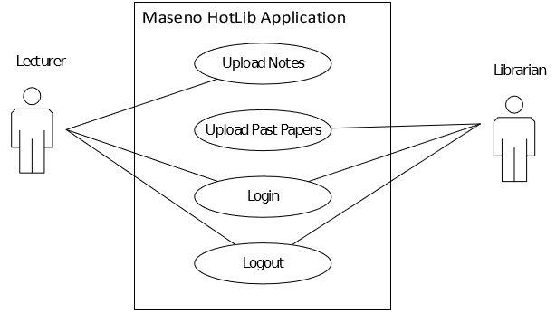

The Lecturers’ use cases are described here:

**Use Case name:** Login/Logout

* + **Description:** This use case describes the scenario where the lecturer logs into the application, with the username and password he has provided while registering with the system.
  + **Actor:** Lecturer.
  + **Input:** The Lecturer creates a username and password at the time of registering with the system. He then uses them to logon to the system.
  + **Output:** The application then verifies the authenticity of the username and password that the lecturer has provided and allows the user to view the information available on the system, if the username and password are valid.

**Use Case name:** Upload notes

* + **Description:** This use case describes the scenario where the lecturer uploads notes to the application.
  + **Actor:** lecturer
  + **Input:** The lecturer logs onto the application with the username and password provided to him/her.
  + **Output:** The application verifies the authenticity of the username and password and then the Lecture notes page is launched for the lecturer to upload

notes.

## The Librarian

The Librarian use cases are described here:

**Use Case name:** Login/Logout

* + **Description:** This use case describes the scenario where the librarian logs into the application, with the username and password he has provided while registering with the system.
  + **Actor:** Librarian.
  + **Input:** The Librarian creates a username and password at the time of registering with the system. He then uses them to logon to the system.
  + **Output:** The application then verifies the authenticity of the username and password that the librarian has provided and allows the user to view the information available on the system, if the username and password are valid.

**Use Case name:** Upload past papers

* + **Description:** This use case describes the scenario where the librarian uploads past examination papers to the application.
  + **Actor:** librarian
  + **Input:** The librarian logs onto the application with the username and password provided to him/her.
  + **Output:** The application verifies the authenticity of the username and password and then the Past papers page is launched for the librarian to upload the past papers.

## ACTIVITY DIAGRAMS

Lecturer and Librarian Registration activity diagram

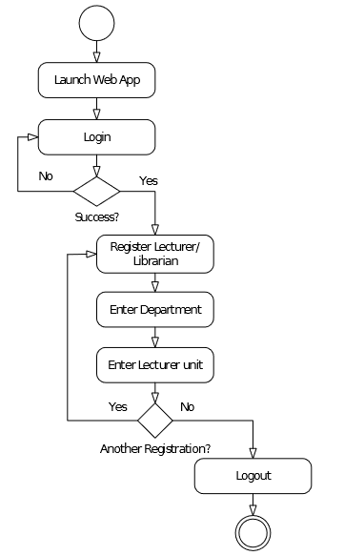

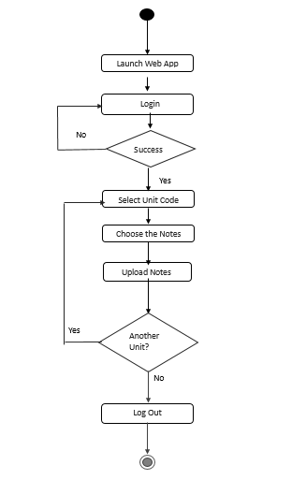

Upload past papers activity diagram.

Upload Lecture Notes activity diagram Login and Registration activity

diagram

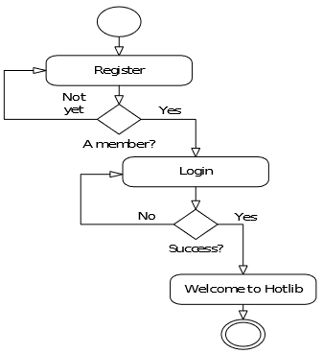

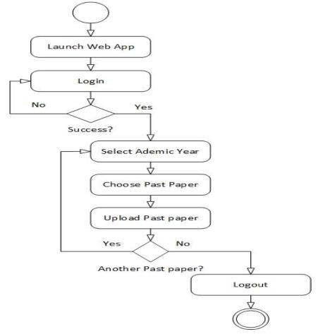

Activity diagram for taking challenges Upload resources activity diagram

39

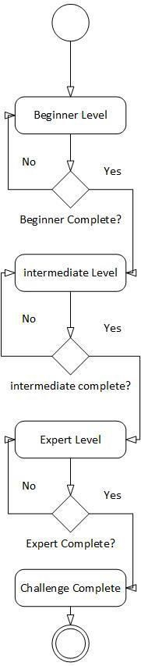 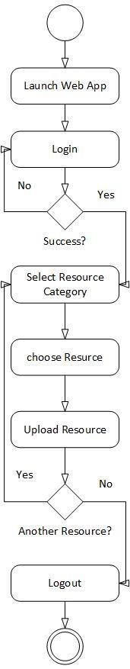

Download lecture notes activity diagram

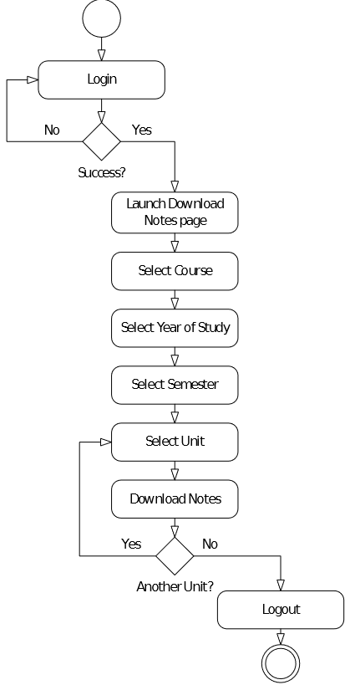

Download Past papers activity

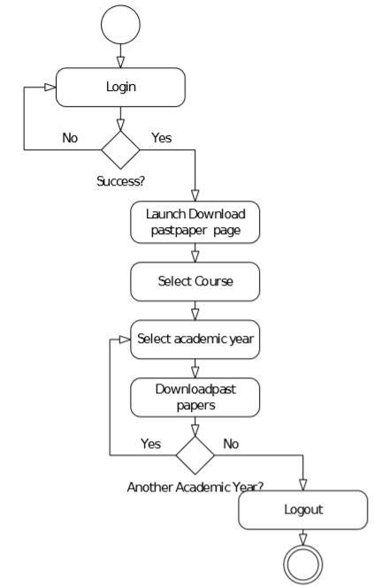

## SYSTEM SEQUENCE DIAGRAM

HotLib Sequence Diagram

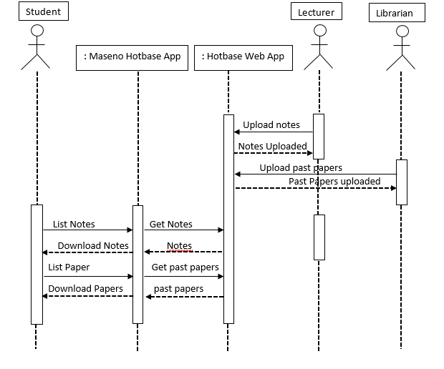

## 3.5.2 DATABASE DESIGN

This design is responsible for defining the structure in which data is to be stored, processed and accessed in the whole system. It will determine the speed of access, efficiency and amount of storage space required by specific files & entries.

|  |  |  |
| --- | --- | --- |
| **No. Table name** | | **Description** |
| **1** | Students | Stores all students’ details |
| **2** | Lectures | Contains all lecturers’ details |
| **3** | Units | Stores unit information |
| **4** | Pastpapers | Stores all past papers |
| **5** | Librarian | Stores all Librarian details |
| **7** | Challenges | Stores the challenges |
| **8** | Courses | Store courses information |
| **9** | Tutorials | Stores the tutorials |
|  |  |  |
| **10** | Admin | Stores admins’ information |
| **11** | Employee_cred | Stores the login credentials for the admin, librarian and the lecturers |
| **12** | Student_cred | Stores login credentials for the student. |

**Table 1: Database tables Schemas derived from relationship sets in the E-R Diagram** takes (ID, Reg_no, challenge_id, score)

std_course (ID, Reg_no, course_code )

course_units (ID, unit_id, course_code)

unit_notes (ID, unit_id, notes_id)

access (ID, reg_no, tutorials_id)

tut_challenge (ID, tutorial_ id, challenge_id)

admin_uploads (ID, emp_id, tutorial_id, challenge_ id, date)

downloads (ID, student_id, notes_id, pastpaper_id, date)

teaches (ID, course_id, lecture_id, unit_code )

lec_uploads (ID, notes_id, lecturer_id, date) lib_uploads (ID, pastpaper_id, librarian_id, date) Registration (ID, emp_id, lecturer_id, librarian_id) Has_cred_std (reg_no, username) Has_emp_cred(emp_id, username)

## Students table

|  |  |  |
| --- | --- | --- |
| ***Attribute Data type*** | | ***Description*** |
| **Reg_no** | Varchar | Students’ Registration number PK |
| **F_name** | Varchar | Students firstname |
| **S_name** | Varchar | Students second name |

**Table 2: Students table**

**Lecturers table**

|  |  |  |
| --- | --- | --- |
| ***Attribute Data type*** | | ***Description*** |
| **Lecturer_id** | Varchar | The ID of the lecturer PK |
| **Emp_id** | Varchar | The Employee ID of the lecturer |
| **F_name** | Varchar | The first name of the lecturer |
| **S_name** | Varchar | The second name of the lecturer |

**Table 3: Lecturers table**

**Units table**

|  |  |  |
| --- | --- | --- |
| ***Attribute Data type*** | | ***Description*** |
| **Unit_id** | Varchar | The Unit ID PK |
| **Unit_name** | Varchar | The unit name of the unit |
| **semester** | Varchar | The semester the unit should be taught |

**Table 4: Units table**

**Pastpapers table**

***Attribute Data type***

***Description***

|  |  |  |
| --- | --- | --- |
| **Pastpaper_id** | Varchar | ID of the pastpaper PK |
| **Course_code** | Varchar | The course code of the past paper |

**Table 5: Pastpapers table**

**Librarian table**

|  |  |  |
| --- | --- | --- |
| ***Attribute Data type*** | | ***Description*** |
| **librarian_id** | Varchar | Librarian’s ID PK |
| **emp_id** | Varchar | The employee id of the librarian FR |
| **F_name** | Varchar | The first name of the librarian |
| **S_name** | Varchar | The second name of the librarian |

**Table 6: Librarian table**

**Notes**

|  |  |  |
| --- | --- | --- |
| ***Attribute Data type*** | | ***Description*** |
| **notes_id** | Varchar | ID of the lecture notes PK |
| **Unit_code** | Varchar | The unit for the notes FK |

**Table 7: Librarian table**

**Courses table**

|  |  |  |
| --- | --- | --- |
| ***Attribute Data type*** | | ***Description*** |
| **course_code** | Varchar | The course id PK |
| **Course_name** | Varchar | The name of the course |

**Table 8: courses table**

**Tutorials table**

|  |  |  |
| --- | --- | --- |
| ***Attribute Data type*** | | ***Description*** |
| **tutorial_id** | Varchar | The ID of the tutorial |
| **Tutorial_name** | Varchar | The name of the tutoial |
| **tutorial _type** | Varchar | The type of the tutorial |

**Employee_cred table**

|  |  |  |
| --- | --- | --- |
| ***Attribute Data type*** | | ***Description*** |
| **Emp_id** | Varchar | The employee id of the user PK |
| **Username** | Varcar | The username of the user |

|  |  |  |
| --- | --- | --- |
| **Password** | Varchar | The password of the user |
| **Email** | Varchar | The email of the user |

**Table 10: employee table**

**Admin table**

|  |  |  |
| --- | --- | --- |
| ***Attribute Data type*** | | ***Description*** |
| **Admin_id** | Varchar | The id of the Admin |
| **Emp_id** | Varchar | The employee id of the admin |
| **F_name** | Varchar | The first name of the admin |
| **S_name** | Varchar | The second name of the employee |

## Table 11: admin table

**Challenges table**

|  |  |  |
| --- | --- | --- |
| ***Attribute Data type*** | | ***Description*** |
| **Challenge_id** | Varchar | The challenge id PK |
| **Challenge_name** | Varchar | The name of the challenge |
| **Challenge_level** | Varchar | The level of the challenge |

## Table 11: challenges table Student_cred table

|  |  |  |
| --- | --- | --- |
| ***Attribute Data type*** | | ***Description*** |
| **Username** | Varcar | The username of the student PK |
| **Password** | Varchar | The password of the student |
| **Email** | Varchar | The email of the student |

**Table 10: student table**

**ERD DIAGRAM**

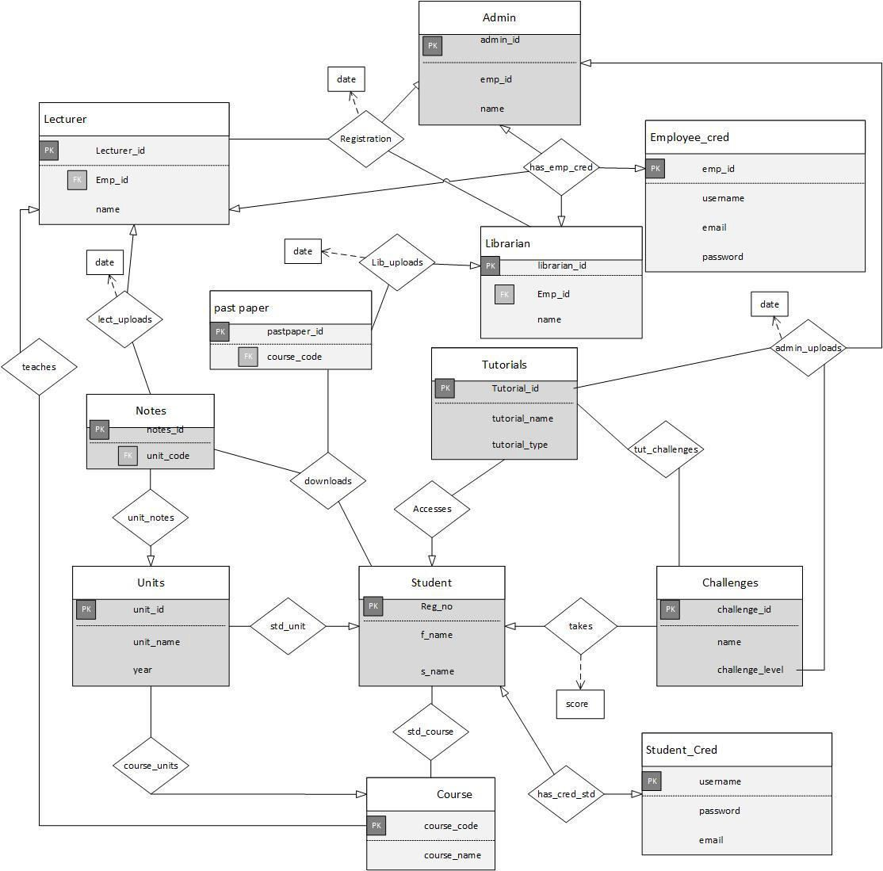

## 3.5.2.1 INTERFACE DESIGN

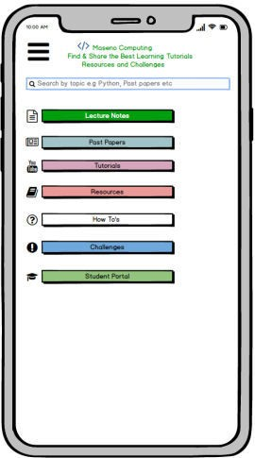 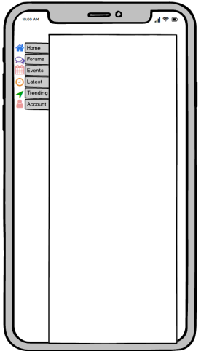

The homepage Navigation

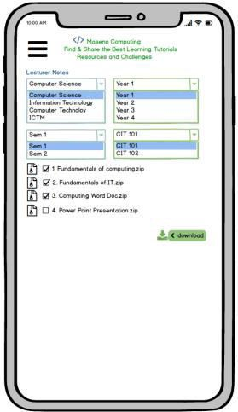

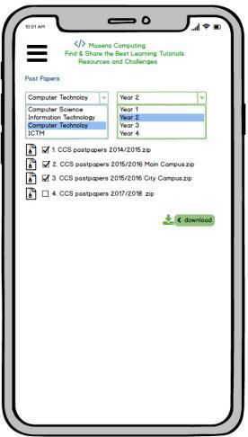

## Lecture notes download past paper download

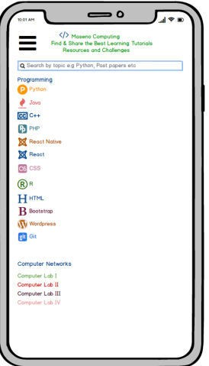 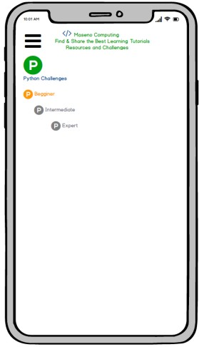

## Tutorials Challenges

## 3.5.3 SYSTEM DEVELOPMENT

## 3.5.3.1 DEVELOPMENT ENVIRONMENT: HARDWARE COMPONENTS

These is a list of hardware components that will be used in the making of the Hotlib application.

System devices include:

A laptop

**Brand:** Toshiba brands was used to develop the application. **Processor:** Intel® Core™2 Duo CPU T8300 @ 2.40GHz × 2 **Hard Disk:** 500GB hard drive was used.

**Brand:** Toshiba Hard disk. **RAM:** 6GB RAM was used **Brand:** Intel chipset 3 DRD Communication devices

Phones are a constant means of communication. A smart phone with an internet connection from various Internet Service Providers.

Additional Hardware

A mouse and external keyboard. And a printer for documentation and printing of questionnaires.

## 3.5.3.1 DEVELOPMENT ENVIRONMENT: SOFTWARE COMPONENTS

` The following are software components used in the making of

## Linux Destro Operating System

Used as the interface between the user and the hardware. Allows installation of Applications.

**Brand:** Kernel Linux 4.18.0-parrot10-amd64 x86_64

## Windows 10 pro

© Microsoft Cooperation.

## Android Studio

Used to develop the android application using Java and XML.

**Version:** Android Studio version 3.5.9

## SR04: Gantt Project

Used to develop a Gantt chart to assist in time allocation per activity

**Version:** 6.57

## SYSTEM TESTING AND EVALUATION

This is the process of evaluating the system and making sure all the errors made during developments are dealt with. Errors that may occur as a result of user input are also tackled in this phase. The system will have different levels of doing the same.

Unit testing- individual units will be tested for bugs.

Integration testing- units that interact with each other will be tested of any bugs System testing- the whole system will be tested for any errors while fully

implemented.

User/acceptance testing- the system will be given to several end users and they will rate usability and user friendliness.

## UNIT TESTING

There are several individual modules to undertake testing. These are upload of notes in a dedicated website, upload of past papers in a dedicated website, download of notes from an android application, download of past papers from an android application, viewing tutorials from an android application, undertaking challenges from an android application, participating in forums from an android application. These units will be tested individually. A perfect unit is a unit with no errors.

## INTEGRATION TESTING.

Several modules require other modules to work. Download of notes require upload of notes for availability. Download of past papers require upload of past papers for availability. Notes and past papers will be uploaded to the website and in the android application there will be a check whether they reflect. A perfect system will allow for smooth integration of both systems.

## SYSTEM TESTING

At the end of development, all the modules having being tested individually and integration checked, will be combined and tested as a whole. The website and the mobile application should work as a single unit. A perfect system should run and integrate all the modules without any errors.

## USER TESTING

Several students from the school of computing Maseno University will interact with the system and give feedback on usability and user friendliness. Lecturers and the librarian will test the website for notes and past papers uploading respectively. A perfect system will receive good comments from users and user should be able to navigate all the modules with ease.

## CHAPTER FOUR

## RESULTS AND DISCUSSIONS

As stipulated in the chapter three above, questionnaires were distributed across a range of actors in Maseno Hotlib application. These questionnaires were later on collected after being filled and the raw data analyzed and tabulated in form of pie charts.

The respondents of the questionnaires included some set students, librarians and lecturers from their large domain.

Lecturers questionnaire was set up to find out how they find notes and resources for revision. this is a survey aimed at finding out the need for an application with the resources and revision material. Sample raw data of the responds is as follows:

|  |  |  |  |  |
| --- | --- | --- | --- | --- |
| **Respondent (Lecturer)** | **No of students Per semester** | **Mode of sending notes** | **% student approach** | **Time the notes are delivered** |
| **Respondent 1** | >200 | Email &  WhatsApp | <10 | Between the semester |
| **Respondent 2** | >100 | Email &  WhatsApp | <10 | Between the semester |
| **Respondent 3** | >200 | Email &  WhatsApp | <10 | End of  semester |
| **Average case** | More than 180 | Email &  WhatsApp | Less than 10 % | Between the semester |

From the tabulated results, it is clear to say that, the lecturers’ lecturer more than 180 students in semester. They use Email and WhatsApp application to send notes to the class representatives who then forwards to the students. Less than 10% of students approach the lecturers outside lecture time for consultations. Most of the lecturers deliver notes the students in between the semester.

The results when represented in a graphs would be as follows.

The number of students were scaled in 15 to represents more than 200 students and 10 to represent more less than 100 students. The media used in sending the resources was summarized as follows: WhatsApp and Email was rated as 9, WhatsApp only at 5 while email only at 4. The notes delivery time was scaled appropriately so that resources sent before the semester begins to be 1, between the semesters to be 6, end of the semester to be 1 and no notes at all to be 2.

Notes as Resource

16

14

12

10

8

6

4

2

0

Respondent 1

Respondent 2

Respondent 3

Respondent 4

Respondent 5

No of Students Media % approach Notes Delivered Time

Librarians questionnaires aided in getting information on how useful the library is in serving the school of computing students and informatics with resources. Sample raw data of the responds is as follows:

|  |  |  |  |  |  |  |
| --- | --- | --- | --- | --- | --- | --- |
| **Respondent (librarian)** | **Availability computer books** | **of science** | **Borrowed books per semester(computer science)%** | **Sought for papers** | **past** | **Computer available to serve students with past papers** |
| **Respondent 1** | available | | 10 | Close examinations | to | 1 |
| **Respondent 2** | available | | 7 | Close examinations | to | 1 |
| **Average case** | Available | | 8.5 | Close examinations | to | 1 |

## The results when represented in a graphs would be as follows.

Resource Allocation

12

10

8

6

4

2

0

Respondent 1

Respondent 2

Availability of Computer Science % Borrowed Books Time for Past papers Available Computers

## CHAPTER FIVE CONCLUSION AND RECOMMENDATIONS

This system will make it easy for students to access resources right through their smart

phones. It will help save time since the application shall contain all types of resources from programming tutorials to Computer networks. Additionally, the students will also download the past examination papers using their mobile phones rather than going to the library. Lecturers will upload their notes/ assignments using Maseno HotLib web app which will then reflect on the android application. Additionally, the librarians will also be able to upload the past examination papers using the same web application. The web app will majorly assist the lecturer, the librarian and the administration in uploading resources in to the application. This will enhance convenience for not only the students but also the lectures in administering lectures. The application will also perform other related tasks such as access to student portal within the application, a forum module for question and answer hangouts and customized url links to direct websites with the application. Therefore, one need not to switch between the applications installed in the android handset. The resources will always be available and therefore can be accessed any time. The system will be very user friendly, simple for the users both lecturers and students to navigate through and also contact the administrator in case of any major issues or challenges they may experience. Usability and functionality of the system will also be enhanced.

The future works on this project would include developing the forum module to assist in asking questions and getting replies from students or any other registered users. It will also extend to other faculties such as School of Mathematics, Medicine, Education any others. The project can even grow farther to serve other universities in the country.

## LIST OF REFERENCES

System analysis and design 5th edition by Alan Dennis (1983)

Software engineering a practitioners’ approach by roger s. Pressman (1982) The unified modeling language reference manual by James Rumbaugh (1999) MySQL administrator bible by Keith murphy and Sheerl Cabral (2009)

Research methodology: methods and techniques 2nd edition by C.R Kothari (1985)

An Introduction to Relational Database Theory 4th edition by Hugh Darwen (2014)

Database System Concepts 6th edition by Abraham Silberschatz, Henry F. Korth, and S. Sudarshan (2011)

Advanced Android Development 2nd Edition by Mark L. Murphy (2009)

Head First Android Development 4th Edition by Dawn Griffiths and Dawn Griffiths (2015).

## APPENDICES GANNT CHART

This is graphical representation with vertical columns listing the activities and horizontal

column showing the time calendar and bars whose length corresponds to the duration of each activity.

|  |  |  |  |  |
| --- | --- | --- | --- | --- |
| **Sub task** | **September** | **October** | **November** | **December** |
| Project ideas |  |  |  |  |
| Chapter 1(introduction) , 2(literature review), 3(system analysis and design) |  |  |  |  |
| Chapter 4(Data  collection and  analysis) and 5(system design) |  |  |  |  |
| Final copy and presentation |  |  |  |  |

## QUESTIONNAIRE 1

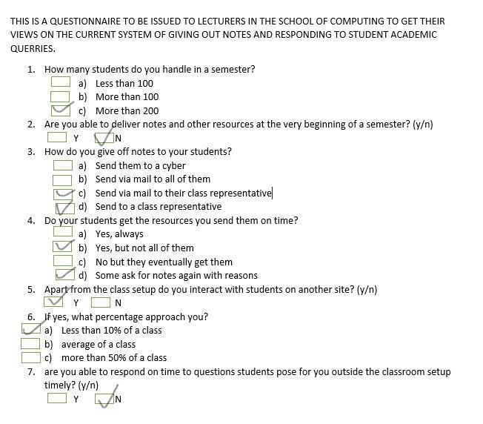

## QUESTIONNAIRE 2

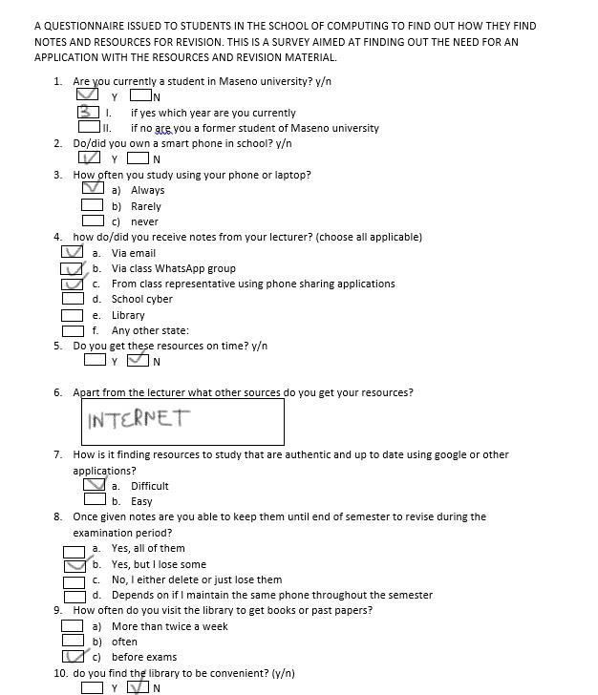

## QUESTIONNAIRE 3

